ASSIGNMENT 20

PRANEESH SHARMA

B22

21052264

Q1. Write a program to display largest element.

Code:

//this program finds the largest element and stores it in the 0th position

#include <stdio.h>

#include <stdlib.h>

int main()

{

    int i=0, n;

    float \*data;

    printf("Enter total number of elements(1 to 100): ");

    scanf("%d", &n);

    data=(float\*)calloc(n,sizeof(float));

    for(i=1;i<n+1;++i)

    {

        printf("Enter Number %d: ", i);

        scanf("%f", data+i);

    }

    for(i=1;i<n+1;++i)

        if(\*data < \*(data+i))

            \*data = \*(data+i);

    printf("Largest element = %.2f", \*data);

    free(data);

    return 0;

}

Output:

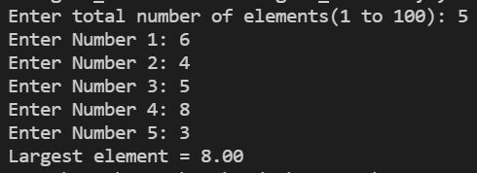

Q2. Write a program to display sum of elements of a 1D array.

Code:

//this program allocates n elements dynamically to a pointer variable, and finds sum of all n elements

#include <stdio.h>

#include <stdlib.h>

int main()

{

    int n, i, \*ptr, sum=0;

    printf("Enter number of elements: ");

    scanf("%d", &n);

    ptr=(int\*)malloc(n\*sizeof(int));

    printf("Enter elements in array: ");

    for(i=0;i<n;++i)

    {

        scanf("%d", ptr+i);

        sum += \*(ptr+i);

    }

    printf("Sum = %d", sum);

    free(ptr);

    return 0;

}

Output:

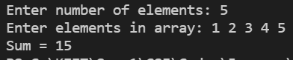

Q3. Write a program to display sum of elements of a 2D array.

Code:

//this program gives sum of elements in a 2D array

#include <stdio.h>

#include <stdlib.h>

int main()

{

    int n, i, j, sum=0;

    int(\*a)[5];

    printf("Enter number of rows: ");

    scanf("%d", &n);

    a=(int(\*)[5]) malloc(n\*5\*sizeof(int));

    for(i=0;i<n;i++)

        for(j=0;j<5;++j)

        {

            printf("Enter element [%d][%d]: ", i+1, j+1);

            scanf("%d", &a[i][j]);

            sum+=a[i][j];

        }

    printf("Sum of elements: %d", sum);

    return 0;

}

Output:

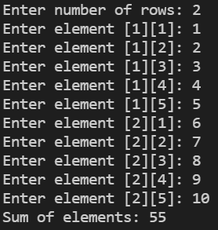

Q4. Write a program to display average score of 10 matches.

Code:

//this program gives the average score of 10 matches

#include <stdio.h>

#include <stdlib.h>

int main()

{

    int i, \*ptr, sum=0, avg;

    ptr=(int\*)malloc(10\*sizeof(int));

    for(i=0;i<10;++i)

    {

        printf("Enter score of Match %d: ", i+1);

        scanf("%d", ptr+i);

        sum += \*(ptr+i);

    }

    avg = sum/10;

    printf("Average score = %d", avg);

    free(ptr);

    return 0;

}

Output:

